#### Traditional IEC approaches

Achieving the goals is usually not fully structured and quantified, the IEC [75-76] chose operations associated with decision-makers' preferences instead of selecting excellent solutions and performed crossover and mutation operations automatically. Figure 14 shows the pipeline of IEC.

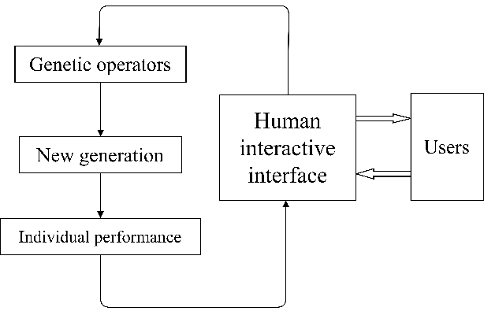

**Figure 14.** A framework of IEC.

To achieve the optimization under the IEC frame, we specified 20 generations and 8 individual species for each generation. Figure 15 shows the manipulated and controlled variables’ populations during the interactive decision-making, where, in regard to the human interface with IEC, the first row is the jacket temperature curve; the second row in green is the acetate concentration and in pink is the diacetyl concentration; and the third row in black stands for the ethanol concentration and that in blue stands for the sugar concentration. Subsequently, the operators assessed the population and chose the best individuals for the next generation.

The initial and tenth interactive decision curves are shown in Figure 15, and the key data during the interactive process are shown in Table 10.

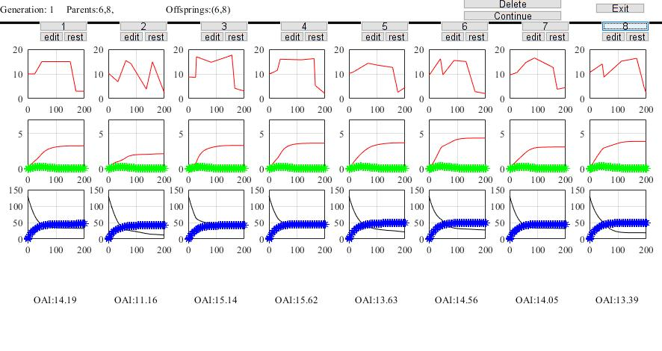

**Figure 15a.** Objectives of the initial population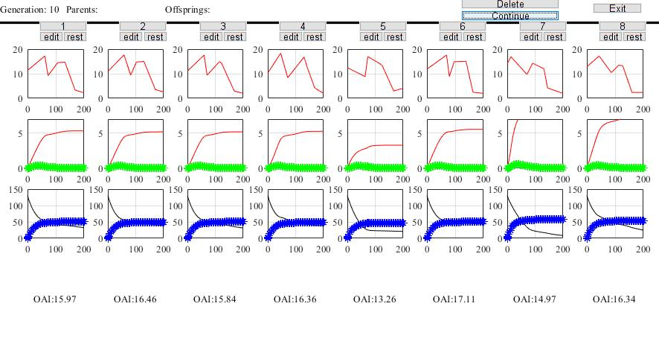

**Figure 15b.** Objectives of the tenth population.

**Table 10.** Key data during the interactive decision

|  |  |  |  |  |  |  |  |  |
| --- | --- | --- | --- | --- | --- | --- | --- | --- |
| Interactive  number | Decision vector (***Temp***) | | | | | | | OAI |
| temp1 | temp2 | temp3 | temp 4 | temp5 | temp6 | temp7 |
| 1 | 9.82 | 11.04 | 13.84 | 15.05 | 13.66 | 5.10 | 2.91 | 12.59 |
| 2 | 10.17 | 10.24 | 14.14 | 15.88 | 11.69 | 4.89 | 3.35 | 12.39 |
| 3 | 12.27 | 9.18 | 14.64 | 15.14 | 12.13 | 5.49 | 3.06 | 12.72 |
| 4 | 12.37 | 9.68 | 15.36 | 14.00 | 14.47 | 3.10 | 2.56 | 13.21 |
| 5 | 13.33 | 9.26 | 16.08 | 14.70 | 12.29 | 6.41 | 3.41 | 13.57 |
| 6 | 11.37 | 10.70 | 14.47 | 15.59 | 13.99 | 5.64 | 3.39 | 13.27 |
| 7 | 11.93 | 11.14 | 13.77 | 15.44 | 12.08 | 4.45 | 2.92 | 13.46 |
| 8 | 12.12 | 13.71 | 13.06 | 17.38 | 10.50 | 5.05 | 3.06 | 15.22 |
| 9 | 12.93 | 13.55 | 14.91 | 17.20 | 10.61 | 5.35 | 3.15 | 16.04 |
| 10 | 12.08 | 13.62 | 13.79 | 13.27 | 11.96 | 10.00 | 3.70 | 14.78 |

As shown in Figure 15, each generation had eight populations. The decision maker could ensure the direction of interaction at the beginning. However, while the number of interactive generation increased, the decision-makers’ fatigue increased, and performance was flat or degraded.

1. **MOEA based on NSGAII and MOEA_D**

Considering four subproblems of this batch beer fermentation models such as: the larger the concentrations of diacetyl and ethanol, the better they were; and the smaller the concentrations of acetic acid and sugar, the better they were, we used two classical MOEA approaches of NSGAII and MOEA_D to optimize the decision vector *Temp* ([temp1, temp 2, temp 3, temp 4, temp5, temp6, temp7]), the main comparative performances are shown in Table 11 and the detailed codes are presented in Appendix.

**Table 11.** Main comparative performances between NSGAII and MOEA_D

|  |  |  |  |
| --- | --- | --- | --- |
| Method | Number of iterations | Optimized decision vector | OAI |
| NSGAII [19] | 50 | ***Temp= [***11.16,12.44,14.65,15.95,14.64,5.98,3.49***]*** | 13.35 |
| MOEA_D [10] | 50 | ***Temp= [***9.00,11.00,13.77,16.01,14.01,5.31,3.23***]*** | 11.07 |

#### Iterative learning control

Similar to the ILC experiment in (3), we used the open-loop learning approach to learn the 10 sets of decision vectors (Table 10) obtained by experts during human–computer interaction. The ILC process was performed 20 times iterations. The detailed parameters of the ILC algorithm are shown in Table 12.

**Table 12**. Detailed parameters of the ILC algorithm

|  |  |  |  |
| --- | --- | --- | --- |
|  | Undetermined parameters  (***Temp***) | Number of iterations | Manipulation updating factor |
| Values | [temp1, temp 2, temp 3, temp 4, temp5, temp6, temp7] | 20 | 0.3 |

Based on the obtained optimum decision vector ***Temp*** (temp1 =12.1074, temp 2 =13.6995, temp 3 =13.0442, temp 4 =17.3647, temp5 =10.4871, temp6 =5.0440, and temp7 = 3.0563), the OAI was achieved as 15.20 after ILC running. Figure 16 shows the response curve based on the ILC approach.

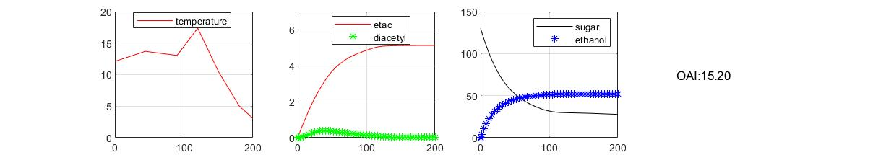

**Figure 16.** Response curve based on the ILC approach.

#### Reinforcement learning

In this experiment, we used an RL Agent to optimize the ***Temp*** (Equation (24)), which was designed as the output actor of the RL Agent. The parameters of the RL system of this batch beer fermentation are shown in **Appendix**. Subsequently, the reward function was as follows:

$reward=10\left(etac≥4\right)-5\left(etac<4\right)+10\left(\left|diacetyl_{error}\right|<0.1\right)-5\left(\left|diacetyl_{error}\right|≥0.1\right)+10\left(sugar≤15\right)-5\left(sugar>15\right)+10\left(ethanol≥50\right)-5\left(ethanol<50\right)$ (28)

The maximum number of training episodes was 100 times, the maximum simulation time within each episode was 200 s, and the training stopped when the average reward of the agent reached 1000.

The response curve based on obtained ***Temp*** ([12, 13, 10, 16, 12, 8, 3]) is shown in Figure 17.

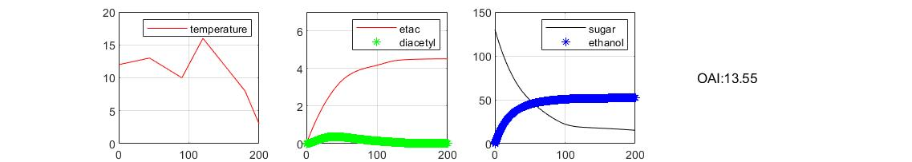

**Figure 17.** Response curves based on the DDPG approach.